Nombre _______________________________________
Vocab 4-2
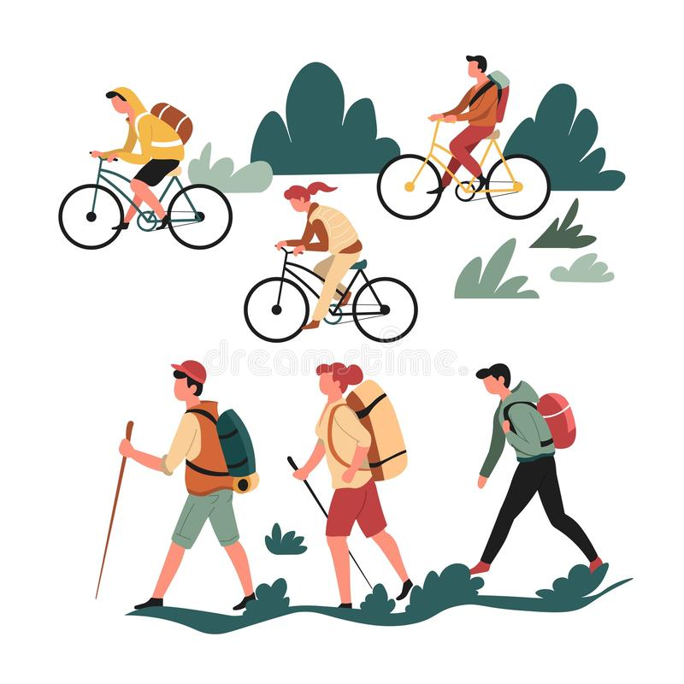
(p. 150)

Pasatiempos
- to skateboard __________________________________________
- to scuba dive ______________________________________
- to climb mountains ____________________________________
- to write an e-mail _________________________________________
- to ski ______________________________________________
- to win ____________________________________________________
- to go on a hike ____________________________________________________
- to read a newspaper ____________________________________________________
- to read a magazine ____________________________________________________
- to swim ____________________________________________________
- to take a walk ___________________________________________________
- to ride a bicycle _________________________________________________
- to skate ____________________________________________________
- to sunbathe ____________________________________________________
- to watch movies ____________________________________________________
- to visit monuments ____________________________________________________
- fun activity; entertainment ____________________________________________________
- fun divertido(a)
- weekend ____________________________________________________
- pastime; hobby ____________________________________________________
- video game ____________________________________________________

SENTENCE PRACTICE 1

1. ___________________________________________________________________________
_____________________________________________________________________________

2. ___________________________________________________________________________
_____________________________________________________________________________

3.____________________________________________________________________________
______________________________________________________________________________

SENTENCE PRACTICE 2
1. ___________________________________________________________________________
_____________________________________________________________________________

2. ___________________________________________________________________________
_____________________________________________________________________________

3.____________________________________________________________________________
______________________________________________________________________________

