Nombre _______________________________________
Vocab 4-1
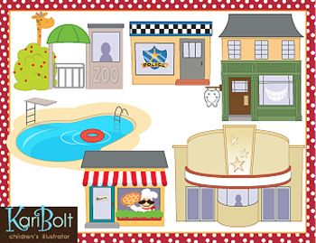
(p. 150)

Lugares

- café __________________________________________

- downtown ______________________________________

- movie theater ____________________________________

- gymnasium ________________________________________

- church ______________________________________________

- place ____________________________________________________

- museum ____________________________________________________

- park ____________________________________________________

- swimming pool ____________________________________________________

- city or town square ____________________________________________________

- restaurant ___________________________________________________

- pharmacy _________________________________________________

- store ____________________________________________________

- shopping mall ____________________________________________________

- supermarket ____________________________________________________

- zoo ____________________________________________________

SENTENCE PRACTICE 1

1. ___________________________________________________________________________
_____________________________________________________________________________

2. ___________________________________________________________________________
_____________________________________________________________________________

3.____________________________________________________________________________
______________________________________________________________________________

SENTENCE PRACTICE 2
1. ___________________________________________________________________________
_____________________________________________________________________________

2. ___________________________________________________________________________
_____________________________________________________________________________

3.____________________________________________________________________________
______________________________________________________________________________

