Nombre _______________________________________
Vocab 3-1

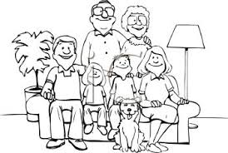
(p. 114)

1. grandfather _______________________________

2. grandmother ___________________________________

3. grandparents* ____________________________________

4. family _______________________________

5. brother _______________________________

6. sister _______________________________

7. brothers, brother & sisters* (siblings) _______________________________

8. son/daughter _______________________________

9. children*_______________________________

10. stepmother ______________________________

11. mother _______________________________

12. stepfather _______________________________

13. father _______________________________

14. parents* _______________________________

15. relatives _______________________________

16. cousin _______________________________

17. uncle/aunt* _______________________________

18. friend _______________________________

19. child _______________________________

20. boyfriend/girlfriend _______________________________

21. person _______________________________

22. cat _______________________________
*the masculine plural forms can refer to mixed groups of males and females
23. dog _______________________________

SENTENCE PRACTICE 1

1. ___________________________________________________________________________
_____________________________________________________________________________

2. ___________________________________________________________________________
_____________________________________________________________________________

3.____________________________________________________________________________
______________________________________________________________________________

SENTENCE PRACTICE 2
1. ___________________________________________________________________________
_____________________________________________________________________________

2. ___________________________________________________________________________
_____________________________________________________________________________

3.____________________________________________________________________________
______________________________________________________________________________

