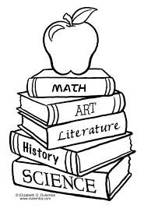
Nombre _______________________________________
Vocab 2-3

La Clase (p. 76)

1. lunch el almuerzo
2. art _______________________________

3. biology _______________________________

4. sciences _______________________________

5. Spanish _______________________________

6. history _______________________________

7. English _______________________________

8. mathematics _______________________________

9. music ______________________________

10. Where (to)? _______________________________

11. now ____________________________________________

12. Which; Which one(s)? _______________________________

13. Why? _______________________________

14. because_______________________________

SENTENCE PRACTICE 1

1. ___________________________________________________________________________
_____________________________________________________________________________

2. ___________________________________________________________________________
_____________________________________________________________________________

3.____________________________________________________________________________
______________________________________________________________________________

SENTENCE PRACTICE 2
1. ___________________________________________________________________________
_____________________________________________________________________________

2. ___________________________________________________________________________
_____________________________________________________________________________

3.____________________________________________________________________________
______________________________________________________________________________

