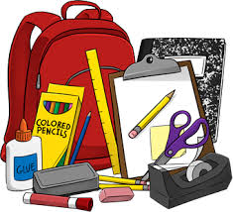
Nombre _______________________________________
Vocab 2-2

(p. 76)

1. classmate _______________________________
2. eraser _______________________________
3. calculator _______________________________
4. desk _______________________________
5. book _______________________________
6. table _______________________________
7. backpack _______________________________
8. paper _______________________________
9. blackboard/whiteboard ______________________________
10. pen _______________________________
11. door ____________________________________________
12. clock; watch _______________________________
13. seat _______________________________
14. window _______________________________
15. library __________________________
16. cafeteria _______________________________
17. house; home _______________________
18. office la oficina
19. bathroom el baño
20. gym el gimnasio
21. class _______________________________
22. test; exam _______________________________
23. schedule _______________________________ 25. semester ______________________________
24. test; quiz _______________________________ 26. homework _____________________________

SENTENCE PRACTICE 1

1. ___________________________________________________________________________
_____________________________________________________________________________

2. ___________________________________________________________________________
_____________________________________________________________________________

3.____________________________________________________________________________
______________________________________________________________________________

SENTENCE PRACTICE 2
1. ___________________________________________________________________________
_____________________________________________________________________________

2. ___________________________________________________________________________
_____________________________________________________________________________

3.____________________________________________________________________________
______________________________________________________________________________

