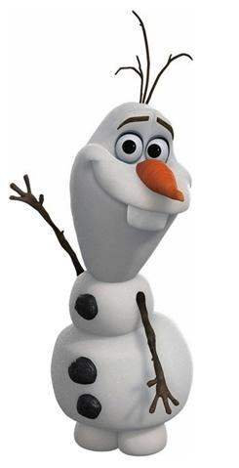
Prelim
1

Nombre:______________________________

Vocab 1-1

EL VOCABULARIO p. 38

Saludos

- Hello; Hi _______________________________________
- Good morning. _______________________________________
- Good afternoon. _______________________________________
- Good evening; Good night. _______________________________________
Despedidas
- Goodbye. _______________________________________
- See you. _______________________________________
- See you later. _______________________________________
- See you later. _______________________________________
- See you soon. _______________________________________
- See you tomorrow. _______________________________________
¿Cómo está?
- How are you? (formal) ___________________________________________
- How are you? (familiar) ___________________________________________
- What’s happening?; What’s going on? _______________________________________
- How are you?; How is it going? ______________________________________________
- (Very) well, thanks. _____________________________________________
- Nothing. _________________________________________________
- Not very well. __________________________________________________
- So-so; OK. ________________________________________________
Expresiones de cortesía
- Pardon me; Excuse me. _____________________________________
- You’re welcome. _____________________________________________
- I’m sorry. _____________________________________
- Thank you (very much); Thanks (a lot). _____________________________________
- Pardon me; Excuse me. _____________________________________
- please _____________________________________
- Mr.; sir __________________
- Mrs.; ma’am ___________________
- Miss _______________________

SENTENCE PRACTICE 1
1. ___________________________________________________________________________
_____________________________________________________________________________

2. ___________________________________________________________________________
_____________________________________________________________________________

3.____________________________________________________________________________
______________________________________________________________________________
SENTENCE PRACTICE 2
1. ___________________________________________________________________________
_____________________________________________________________________________

2. ___________________________________________________________________________
_____________________________________________________________________________

3.____________________________________________________________________________
______________________________________________________________________________

