Nombre: ________________________________
Vocab 1-6
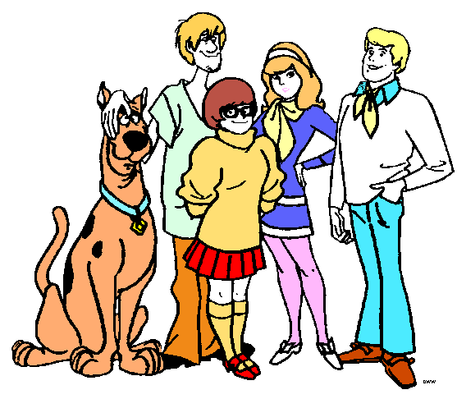

Adjetivos p. 114

1. tall ________________________________________________
2. unpleasant _______________________________________________
3. short __________________________________________________
4. pretty __________________________________________________
5. good __________________________________________________
6. thin __________________________________________________
7. difficult __________________________________________________
8. easy __________________________________________________
9. big __________________________________________________
10. good-looking __________________________________________________
11. important __________________________________________________
12. intelligent __________________________________________________
13. interesting __________________________________________________
14. young __________________________________________________
15. bad __________________________________________________
16. same __________________________________________________
17. brunette __________________________________________________
18. Much, many __________________________________________________
19. red-haired __________________________________________________
20. small __________________________________________________
21. blonde __________________________________________________
22. nice __________________________________________________
23. hard-working __________________________________________________
24. old __________________________________________________

SENTENCE PRACTICE 1

1. ___________________________________________________________________________
_____________________________________________________________________________

2. ___________________________________________________________________________
_____________________________________________________________________________

3.____________________________________________________________________________
______________________________________________________________________________

SENTENCE PRACTICE 2
1. ___________________________________________________________________________
_____________________________________________________________________________

2. ___________________________________________________________________________
_____________________________________________________________________________

3.____________________________________________________________________________
______________________________________________________________________________

