Nombre: ______________________________________
Vocab 1-3

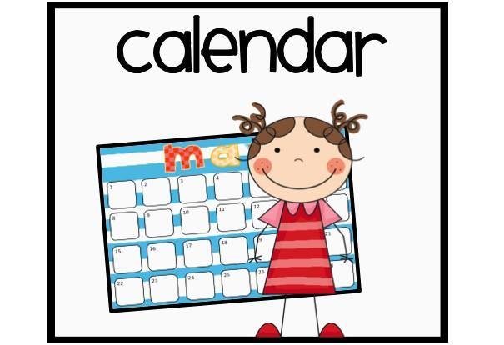

Los días de la semana p. 76

- When?______________________________________
- What day is it? _____________________________________
- Today is __________________________________________
- week ______________________________
- Monday _________________________
- Tuesday _________________________
- Wednesday_________________________
- Thursday _________________________
- Friday _________________________
- Saturday _________________________
- Sunday _________________________

Meses del Año (Months) p. 154
12. January __________________________
13. February _________________________
14. March __________________________
15. April ___________________
16. May ___________________
17. June ___________________
18. July ___________________
19. August ___________________
20. September ___________________
21. October _____________________
22. November_____________________
23. December_____________________

Números 11-20 p. 16

24. Eleven (11) ___________________________________________
25. Twelve (12) ___________________________________________
26. Thirteen (13) ______________________________________________
27. Fourteen (14) _____________________________________________
28. Fifteen (15) _________________________________________________
29. Sixteen (16) _________________________________________________
30. Seventeen (17)_________________________________________________
31. Eighteen (18) _________________________________________________
32. Nineteen (19) _________________________________________________
33. Twenty (20) _________________________________________________

SENTENCE PRACTICE 1

1. ___________________________________________________________________________
_____________________________________________________________________________

2. ___________________________________________________________________________
_____________________________________________________________________________

3.____________________________________________________________________________
______________________________________________________________________________
SENTENCE PRACTICE 2
1. ___________________________________________________________________________
_____________________________________________________________________________

2. ___________________________________________________________________________
_____________________________________________________________________________

3.____________________________________________________________________________
______________________________________________________________________________

