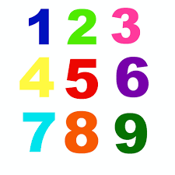
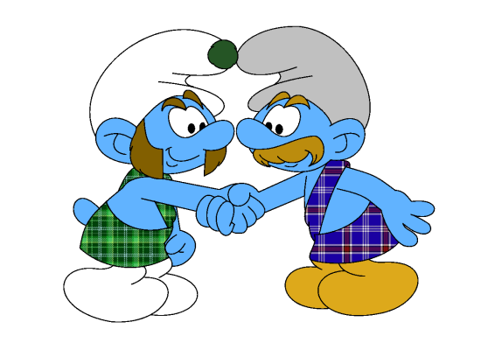
Nombre: ________________________________
Prelim
2

Vocab 1-2

EL VOCABULARIO p. 38

Presentaciones

- What’s your name? (formal) _______________________________________
- What’s your name? (familiar) __________________________________
- My name is . . .____________________________________________
- And you? (formal) ______________________________
- And you? (familiar) _____________________________
- Pleased to meet you. _______________________________________
- Delighted/Pleased to meet you ________________________________________
- Likewise __________________________________________________
- I would like to introduce you to (name). (familiar) _______________________________
- name__________________________________________________

¿De dónde es?

- Where are you from? (formal) _____________________________________
- Where are you from? (familiar) ____________________________________
- I am from … _____________________________________

NUMBERS 0-10 p. 16

- Zero (0) _____________________
- One (1) _____________________
- Two (2) _____________________
- Three (3) _____________________
- Four (4) _____________________
- Five (5) _____________________
- Six (6) _____________________
- Seven (7) _____________________
- Eight _____________________
- Nine _____________________
- Ten _____________________

SENTENCE PRACTICE 1

1. ___________________________________________________________________________
_____________________________________________________________________________

2. ___________________________________________________________________________
_____________________________________________________________________________

3.____________________________________________________________________________
______________________________________________________________________________
SENTENCE PRACTICE 2
1. ___________________________________________________________________________
_____________________________________________________________________________

2. ___________________________________________________________________________
_____________________________________________________________________________

3.____________________________________________________________________________
______________________________________________________________________________

