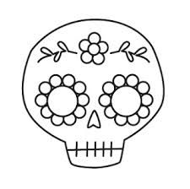

Nombre: ____________________________

Nombre:____________________________

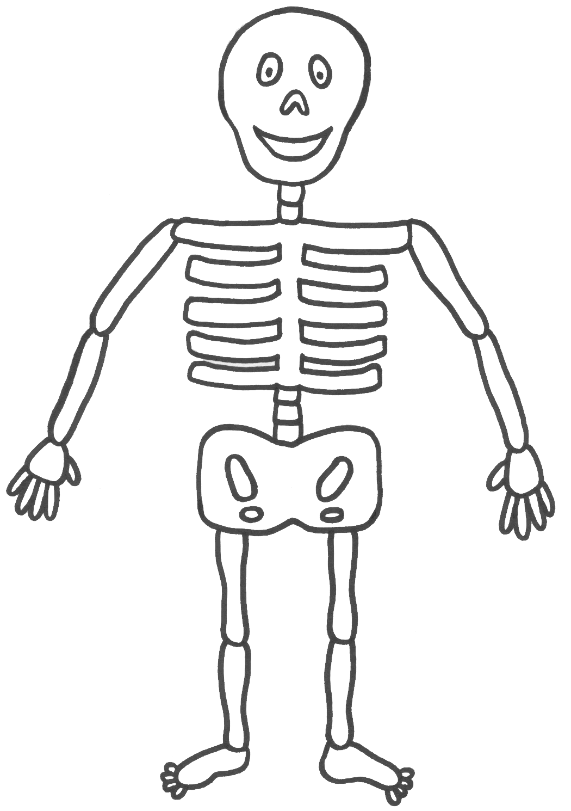

SUBJECT PRONOUNS

we

I

you

you all

(in Spain)

he/she

they

you (formal)

you all

MC900326428[1]SUBJECT PRONOUNS

Which subject pronoun would replace each noun below?

myself ___________________ ___________________

English Spanish

The women ___________________ ___________________

English Spanish

Talking directly to my friend ___________________ ___________________

English Spanish

Marco ___________________ ___________________

English Spanish

Talking directly to ___________________ ___________________

You and Marco and Stephen English Spanish

Talking directly to my teacher ___________________ ___________________

English Spanish

My friends and I ___________________ ___________________

English Spanish

The boys ___________________ ___________________

English Spanish

María ___________________ ___________________

English Spanish